Website Update Requests: Sacred Origins NYC
Hi Shaikh,

Please see below for the structured feedback and minor updates requested for the new Sacred Origins website.

1. Hero Section Button Updates
The primary call-to-action buttons in the Hero section require the following adjustments to better align with our user journey:

Current Button Label | Requested Change | Target Link
"Schedule a Call" | "Contact Us" | Contact Page
"Meet Sacred Origins" | "Shop the Apothecary" | Shop Page


4. Large Monitor Formatting & Responsive Design Fixes
Visual alignment issues have been identified when viewing the site on widescreen and high-resolution monitors. Please address the following:
Grid & Alignment: Ensure multi-column sections (such as Offerings/Services and Testimonial cards) maintain proper grid constraints and maximum widths. Cards should not stretch excessively, and hanging items should be centered or balanced.
Footer Spacing: Adjust spacing and layout constraints in the site footer to ensure elements remain properly grouped and balanced on resolutions exceeding 1920px
.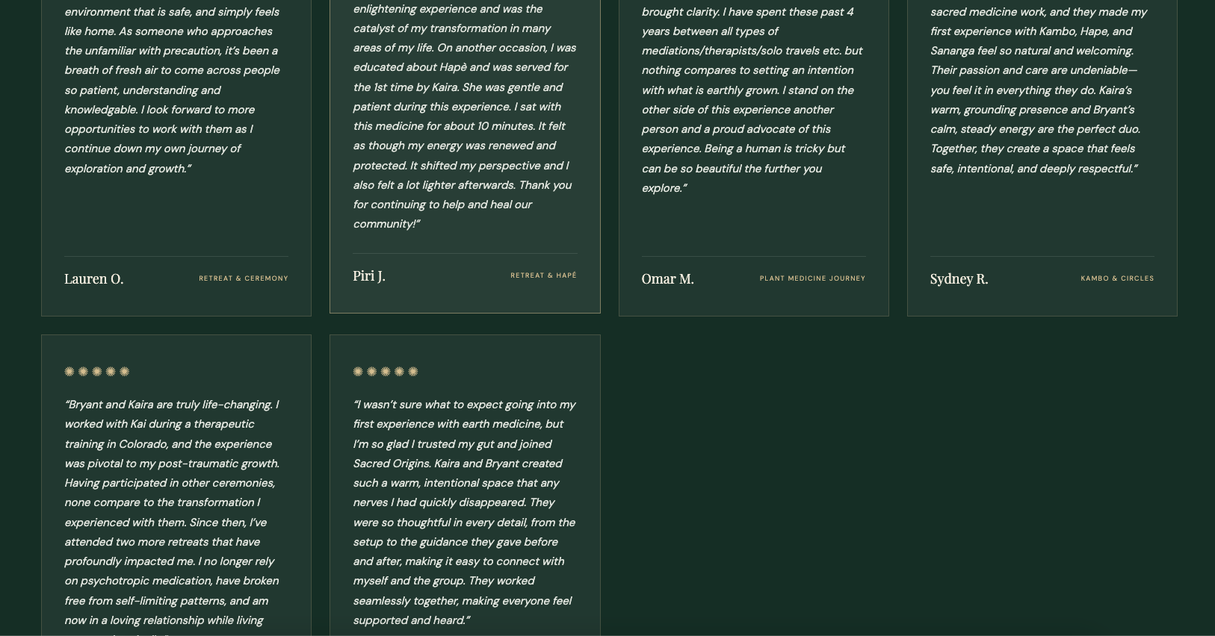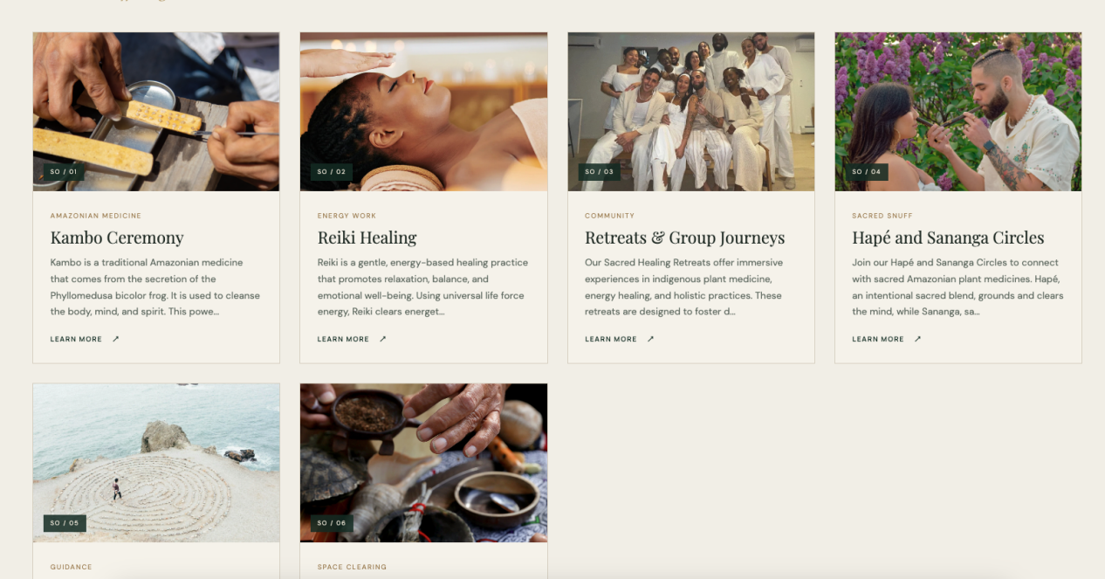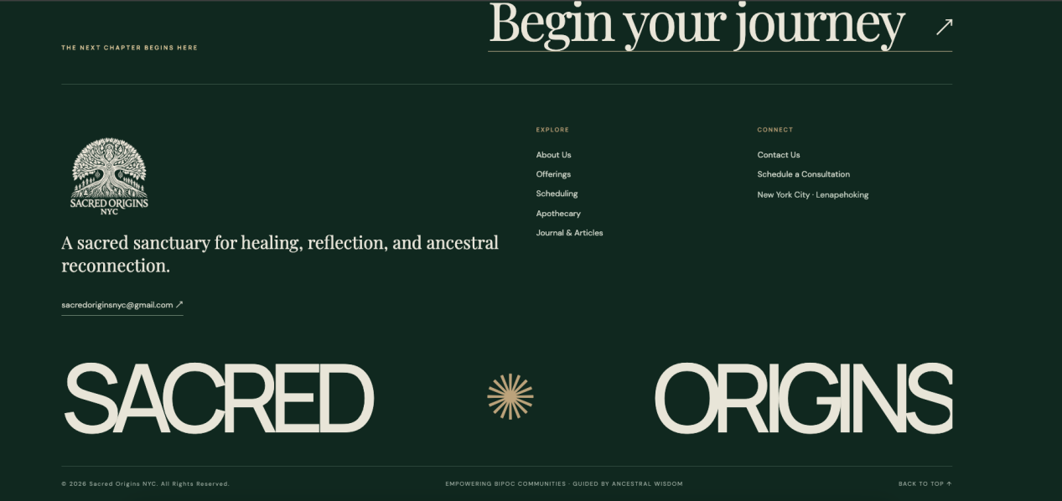

Copy Updates
Please refine the following text elements to ensure brand consistency and clarity:
Apothecary Section Button: Change the call-to-action link text from "ENTER THE COLLECTION" to "ENTER THE APOTHECARY".

Callout Banner Heading: Update the banner text from "Find your way back to center." to "Find your way back to your center."
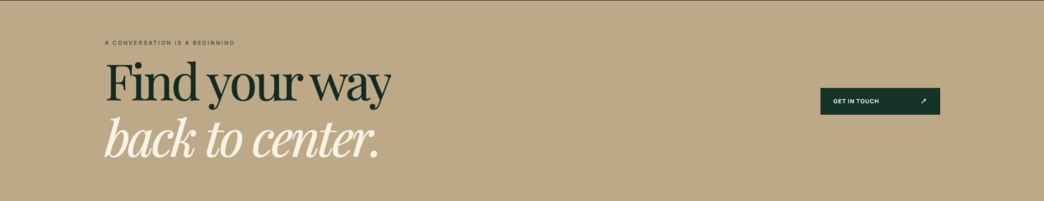

New Testimonials & Client Reviews
Please integrate the following two testimonials into the existing reviews section of the site:
Review 1:
"If you're looking to start your healing journey or continue it, I highly recommend Sacred Origins NYC. The care and hard work I saw and experienced both through the retreat and local group work is admirable. There's a lot of care and intentionality that went into ensuring that the practices remain sacred and that the journey feels safe. It's suitable for those who are less outgoing and for those who are more comfortable taking up space since there is a balance of group and private time. I was able to receive/grow not only from the moments I engaged with the practices, but also from the private moments and curated group ones. Looking forward to the next retreat!"— Clarimar
Review 2:
"I have no words to describe how amazing my spiritual retreat experience was with Sacred Origins, I am deeply thankful for everything. I can’t wait for the next retreat."— Alexander

